**JAC444 - Lecture 6**

Java Input / Output

Segment 2 - File I/O

**Objectives**

**Upon completion of this lecture, you should be able to:**

* Examine Reader / Writer in Java
* Contrast CharacterStream and ByteStream
* Work with Buffered Stream
* Design and Develop File I/O programs

**Reader vs InputStream**

* **Reader** and **InputStream** define similar methods, but for different data types.
* **Reader *–*** Reading characters and array of characters**.**
* **int read()**
* **int read(char[] cbuf)**
* **int read(char[] cbuf, int offset, int length)**
* **InputStream *–*** Reading bytes and array of bytes.
* **int read()**
* **int read(byte[] cbuf)**
* **int read(byte[] cbuf, int offset, int length)**

**File Streams Example**

import java.io.*; public class Copy {

public static void main(String[] args) throws IOException { File inputFile = new File("args[0]"); //source

File outputFile = new File("args[1]"); //destination

**FileReader in = new FileReader(inputFile);**  **FileWriter out = new FileWriter(outputFile);**  int c;

while ((c = in.read()) != -1) out.write(c);

in.close(); out.close();

}

}

**Patterns of I/O Class Names**

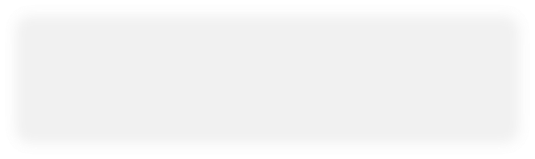

**…**

**Reader**

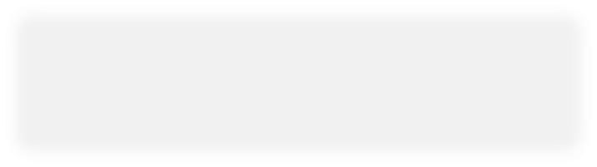

**…**

**Writer**

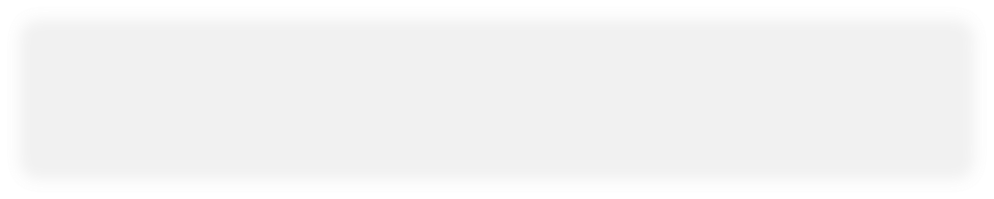

**…**

**InputStream**

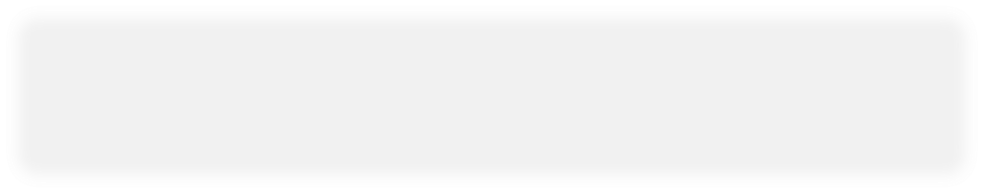

**…**

**OutputStream**

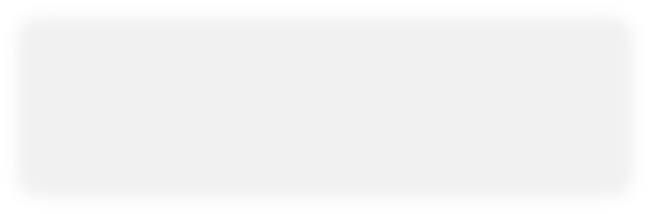

**Buffered**



**Buffered**



**Buffered**

CharacterStream

ByteStream

Filter

LineNumber

Pushback

Print

Process Type

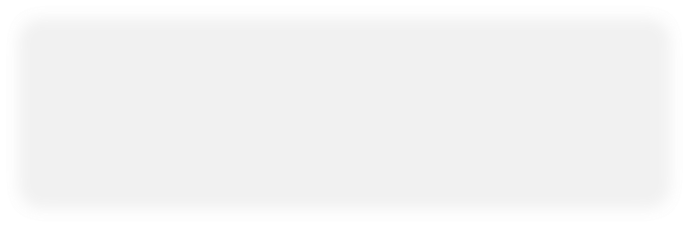

**Buffered**

**Concatenate utility**

**import java.io.*;** **public class Concatenate { public static void main(String[] args) throws IOException { ListOfFiles list = new ListOfFiles(args);**

**SequenceInputStream s = new SequenceInputStream(list); int c;**

**while ((c = s.read()) != -1) System.out.write(c);**

**s.close();**

**}**

**}**

**Conclusion**

**After completion of this segment you should know:**

* How to use files in Java.
* How to read data to and write data from Java files
* Examine **java.io** package for IO data processing .

